

UNITED WORLD SCHOOL Of COMPUTATION
INTELLIGENCE (USCI)

Submitted BY: Devanshu jain
(Enrol. No.: 20220701005)

Title: R Programming

B.Sc. (Hons.) Computer Science / Data Science / AIML
III Semester – July – Nov 2023

USCI
Nov/Dec 2023

esoph( Smoking, Alcohol and (O)esophageal Cancer)

The "esoph" dataset in R is a built-in dataset that comes
with the base R installation. It contains information on
patients with esophageal cancer and is often used for
educational and illustrative purposes in statistical
analyses. Here's a short note about the "esoph" dataset:
The Esoph Dataset in R Programming
The "esoph" dataset is a part of the base R datasets
package and provides valuable information on patients
with esophageal cancer. It was collected to study the
association between smoking habits, alcohol consumption,
and the occurrence of esophageal cancer.

The dataset consists of 88 observations on 5 variables:
agegp: Age group of the patient.
alcgp: Alcohol consumption group (g/day).
tobgp: Smoking status group.
ncases: Number of cases of esophageal cancer.
ncontrols: Number of control subjects without esophageal cancer.
Researchers and data analysts commonly use the "esoph" dataset to perform statistical analyses,
explore relationships between variables, and visualize patterns in the data. Common analyses
include contingency table creation, chi-square tests for independence, odds ratio calculations, and
graphical representations such as bar plots and mosaic plots.
To utilize the "esoph" dataset in R, load it using the data(esoph) command. This dataset serves as
an illustrative resource for learning and practicing statistical techniques within the R programming
environment.

Codes....

Data of esoph from
the dataset
- Input

- Output for the data
esoph

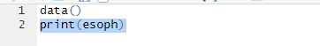

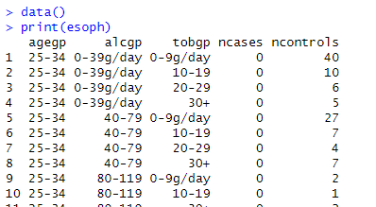

No. of data in from of rows:

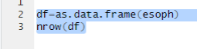

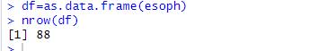

Barplot:

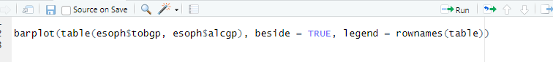
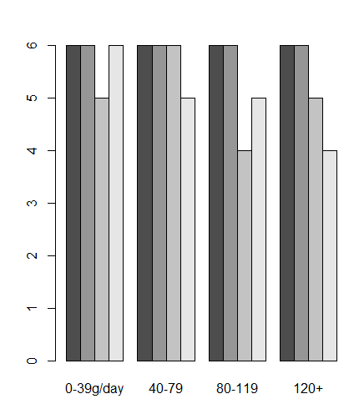

Table data with the margin:

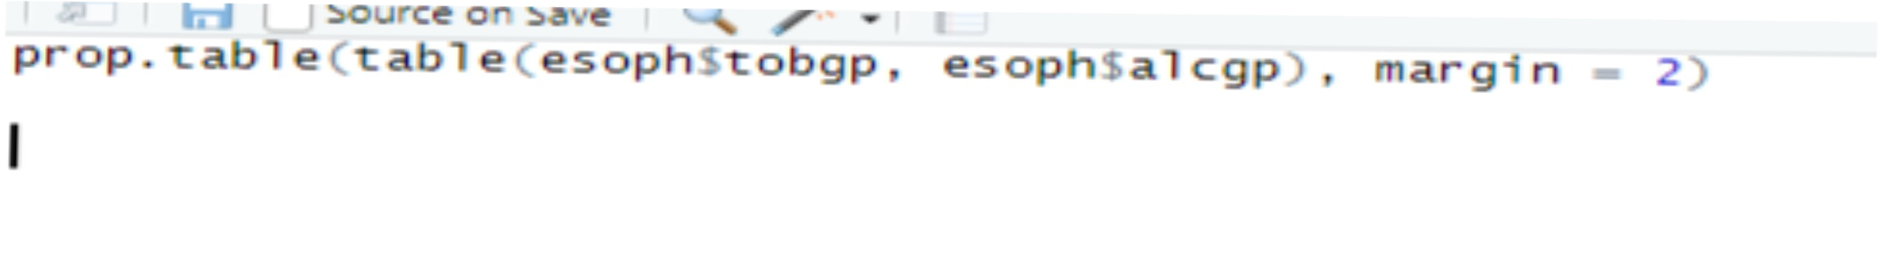
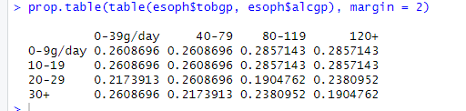

Tail of the dataset(esoph):

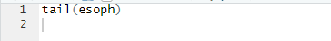
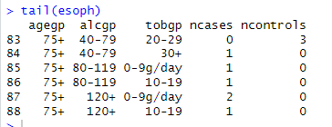

Table format of smokers and alcoholic:
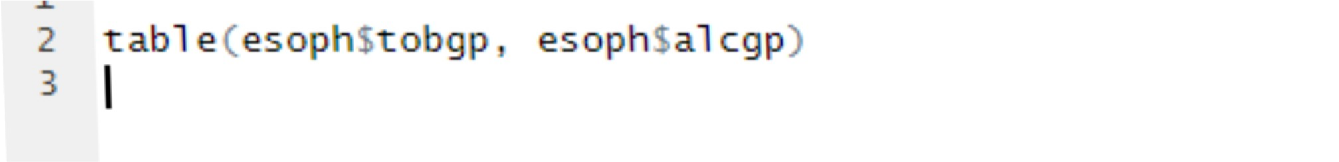
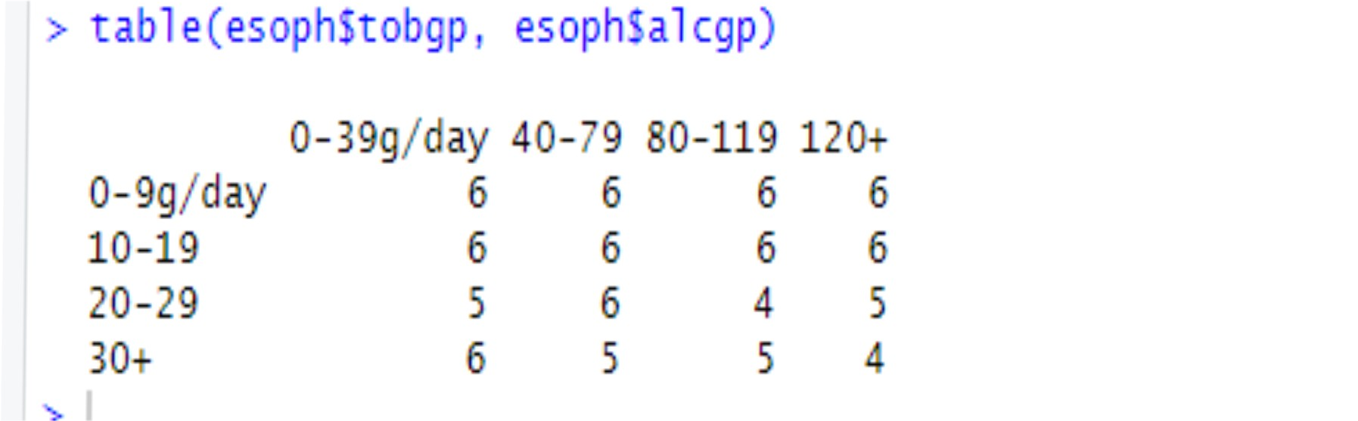

No. of data in from of columns:

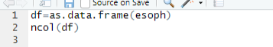
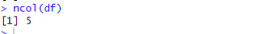

Head of the dataset (esoph):
